Software Construction

Assignment -1

Ibrahim Usmani

Reg# 32929

Class – SE-5B

# Introduction:

This Assignment is about an android game. This game ‘Snakes and Ladder’ is a cliché board game played in every house by kids as well as adults.

# Approach:

I created a ‘snakes and ladders’ board with all the marking of cells on it. On some of the cells there were snakes and on some, ladders. A die is rolled by the user by clicking on the roll button. The dice rolls and randomly give a number. The player piece moves that much spaces on the board. If it is a 6 then player rolls again, otherwise his/her turn ends and AO’s turn starts. AO(Automated Opponent) rolls his own die and move accordingly. If a player lands on a cell with base of a ladder, he/she moves to the head of the ladder. On the contrary if a player lands on a cell with head of a snake, he/she moves to the tail of the snake. The player who reaches 100th cell first, wins. If a player’s die shows a number that adding to his/her current position exceeds 100, then player cannot move, and other player takes turn.

When a player reaches the 100 mark, game ends and his/her victory screen appears.

User icon is the green circle while AO icon is the red one. User die is the red one while AO die is black.

# Novelty:

In this assignment, I learned about many basics of android development as well as the basic functionalities of java along with some complexities. In this assignment, I learnt how to add several items on the layout and inflating that layout afterwards. I learn, how to make new activities and many more of the sort.

# How to run:

Install the APK in your android device and just open the installed application. Or extract the src file and import it into your android studio project and run the project. The only interactive part is the roll button, so interface is quite simple to understand.

# Screenshots:

Player 1 cannot end as it needs 3 to 100 but the die shows 5.

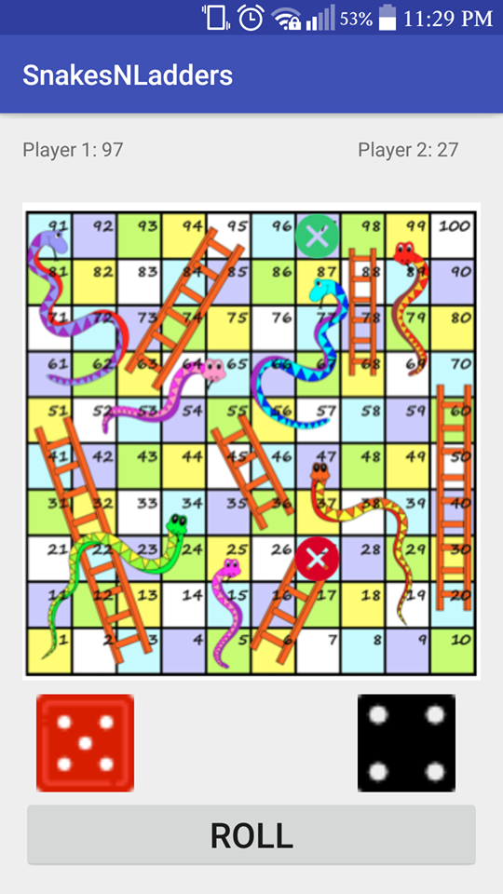

Player 1 got eaten by snake so moved to 69th cell.

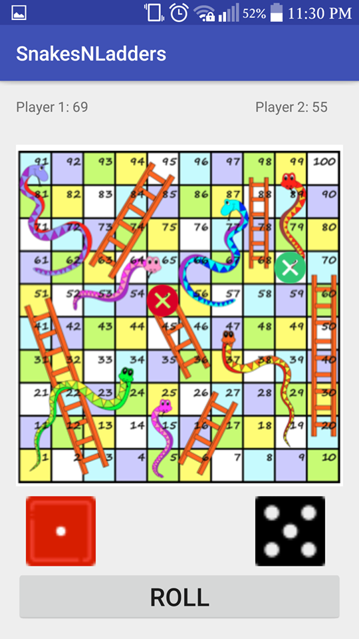

Player 1 wins:

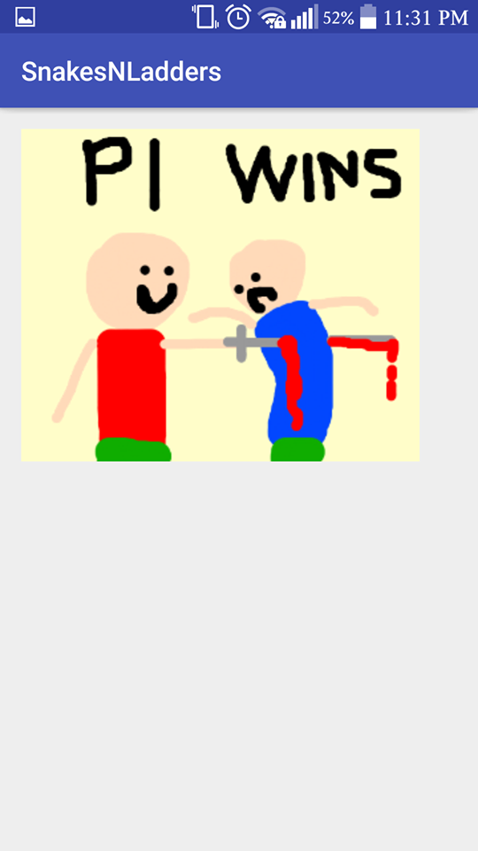

# Link to GitHub repository: - https://github.com/ibrahimusmani/Assignment1